CLASS VII GK WORKSHEET
Give one word using the following clues :-
1.A natural gas crater set on fire by the scientists in the year 1971 to prevent the spread of methane gas. _________________

2.Many species of phyto planktons are known to emit light . They illuminate in the dark at the sea shore _______________

3.Millions of red crabs migrate in this small area to lay eggs. _________________

4. It is a giant submarine sinkhole, circular in shape with 300 m diameter. In Central America. ___________________

5.A dirty thunderstorm is a phenomenon in which lightning occurs. ______________

THE EARTH DAY
- When do we celebrate Earth Day?
___________________________

2.Suggest four ways to celebrate the Earth Day.

__________________________________________________________________________
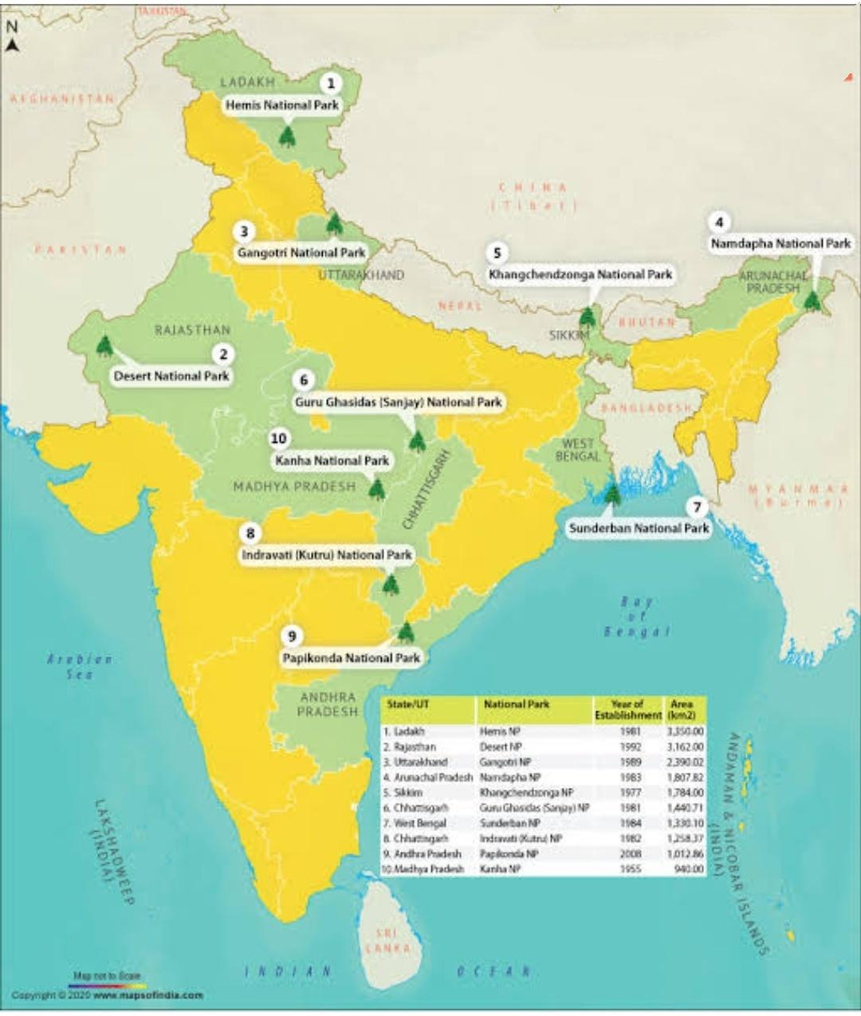
Ten National Parks are located in the above map. Mark the following National Parks in the same map.
1.Dachigam National Park
2.Kaziranga National Park
3.Periyar National Park
4.Gir National Park

