^{English}
^{What are we learning today ?}
Introduction to letter “E” and “F”.
Recapitulation of letter A to F.
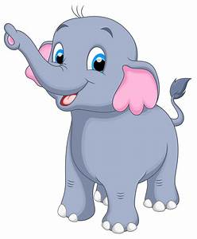
^{Introduction with “E” story.}

^{Eli The Elephant}

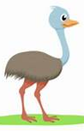
Eli the elephant lived in the jungle. His best friend was Elu the emu. Both the friend loved his to eat egg plant.One day it was Eli’s birthday .All his friends were invited for the party.Only Eva the eagle could not attend the party because she was not well . She had sent Eli ,a birthday card in an envelope through the eel. All the friends enjoyed the birthday party but they missed Eva the eagle.

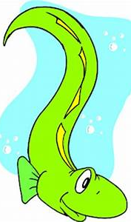
emu
Egg plant
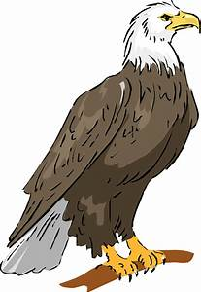
eel

eagle
envelope

Circle the pictures that start with letter E.





Introduction of letter “F”.

Words with letter “F” .


flag

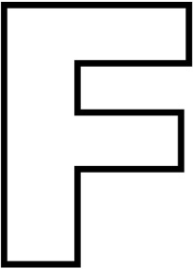
flower

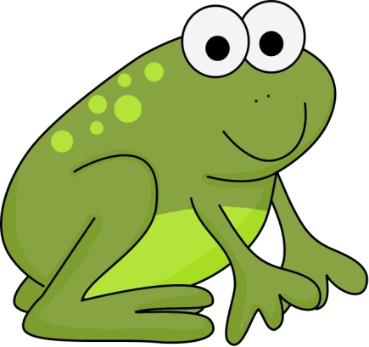
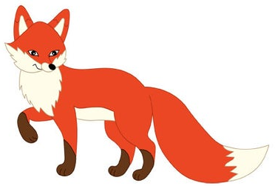

fox

frog
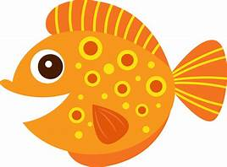
fish


fork

Colour the picture that start with letter “F”

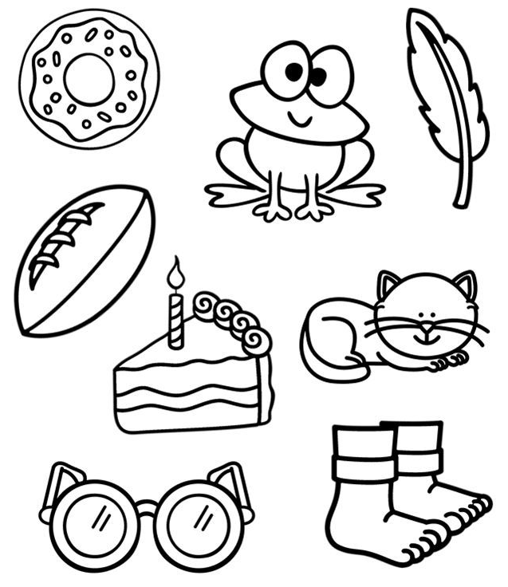

Match the letter with the pictures.

