NORTH POINT SENIOR SECONDARY BOARDING SCHOOL
WORKSHEET
CLASS - KG
ENGLISH
TOPIC: WORD FAMILY (a)

Fill in the blanks according to the picture
 C _ t

 M _ t

 B _ g

 T _ p
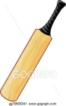

B _ t

