NORTH POINT SENIOR SECONDARY BOARDING SCHOOL
WORKSHEET
CLASS - NURSERY

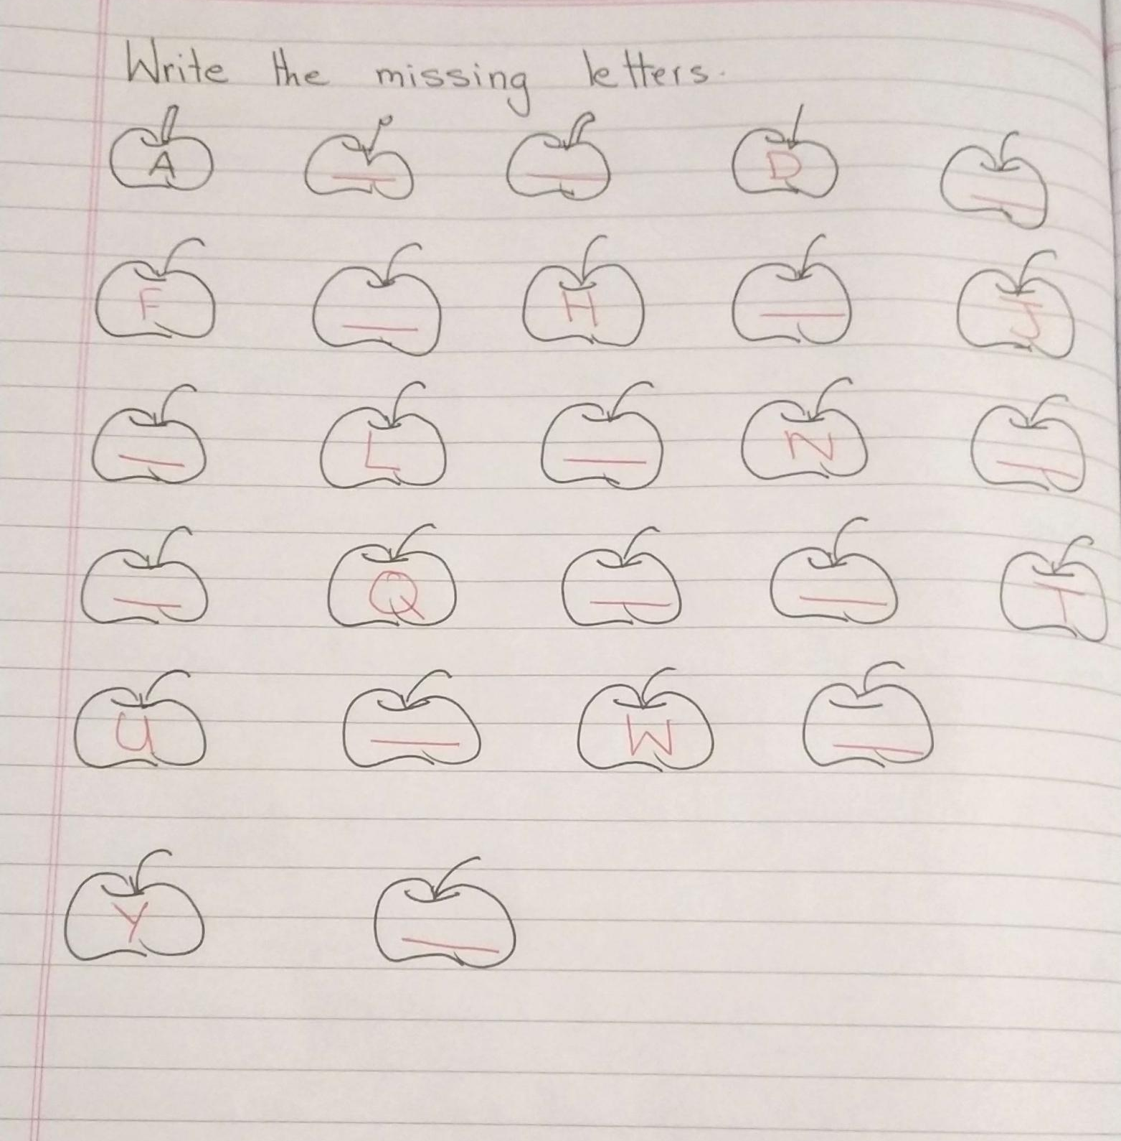
ENGLISH

